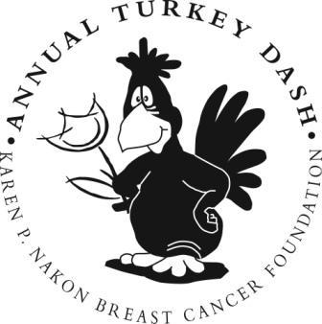

This year we are holding our Annual Turkey Dash 5k run/walk to benefit The Karen P. Nakon Breast Cancer Foundation on Thanksgiving morning, November 22, 2018. In its 15th year, this race has fast become one of the region’s premier races with over 1500 participants last year that included a large number of breast cancer survivors and their families.

The Turkey Dash has raised over $300,000 in the last 14 years in support of the Foundation’s mission to provide financial assistance to families in Northeast Ohio who are impacted by the staggering costs of breast cancer treatment. To date, the Foundation has helped over 800 families with over $1 Million in grants. All proceeds from this event go directly to aid for women facing the challenges of breast cancer and its treatments.

We hope that you will see that our mission and core values align with yours and the Turkey Dash is a healthy way for us to engage a diverse and inclusive audience to raise both awareness for breast cancer and funds for our mission. Please consider supporting the 2018 Turkey Dash. By becoming a sponsor, your donation directly impacts the bottom line of this fundraiser and in turn sending financial aid to those women in Northeast Ohio who are battling breast cancer. All donors are recognized in all of our marketing efforts to promote the race and on our t-shirts and/or gift bags

If you have any questions, please do not hesitate to contact the Foundation’s event coordinator, Stacey Rusher, at 440-933-7621 or by email at info@nakonfoundation.org

For more information about The Nakon Foundation, please, visit our website at www.nakonfoundation.org. Thank you again!

Sincerely,
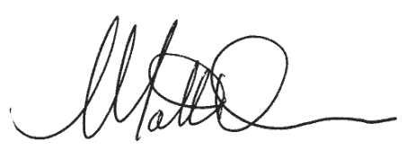

Matthew Nakon
Board President

35765 Chester Road Avon, OH 44011 440.933.7621 www.nakonfoundation.org
Karen P. Nakon Breast Cancer Foundation
15th Annual Turkey Dash
Thursday November 22, 2018
SPONSOR INFORMATION

- Family Friendly 5k run/walk in Avon, Ohio.
- Chip Timing
- One of the largest races on the West Side of Cleveland – over 1500 runners.
- Over 300 fans and friends cheering them on.
- Great way to give thanks and get healthy.
- Pumpkin pie for everyone.
- Over $1 Million in direct aid has been distributed by the Foundation for women in Northeast Ohio struggling with the high cost of breast cancer treatments.
- 100% of the proceeds go to direct financial aid.

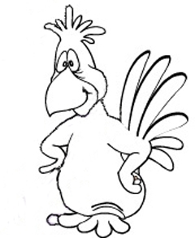
Count me in as a sponsor for the
15th Annual Nakon Foundation Turkey Dash

List me on all the signs and promotional material $ 250
Put my name on the swag $ 500
Make my name a little larger $ 750
Wait – I want my name at the top of the list $1,000
Hang on -
I want to be a lead sponsor for the event $2,500

Put my name where ever you want – here’s how I can help $______

_______________________________________________________________________________
Name as it should be listed

_____________________________________________________________________________
Address City State Zip

_____________________________________________________________________________
Contact Phone Email

____Check Enclosed ____Bill Me ____Use my Logo
(made out to Nakon Foundation) (email logo to info@nakonfoundation.org)

Mail Form and payment to: Nakon Foundation
35765 Chester Road
Avon, OH 44011
440-933-7621

